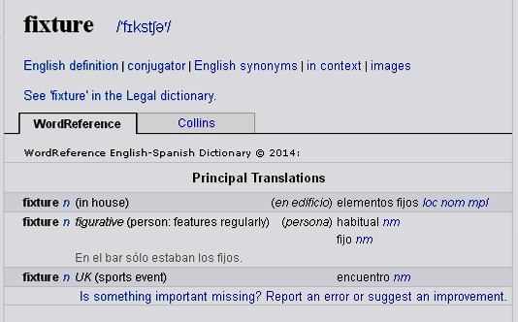
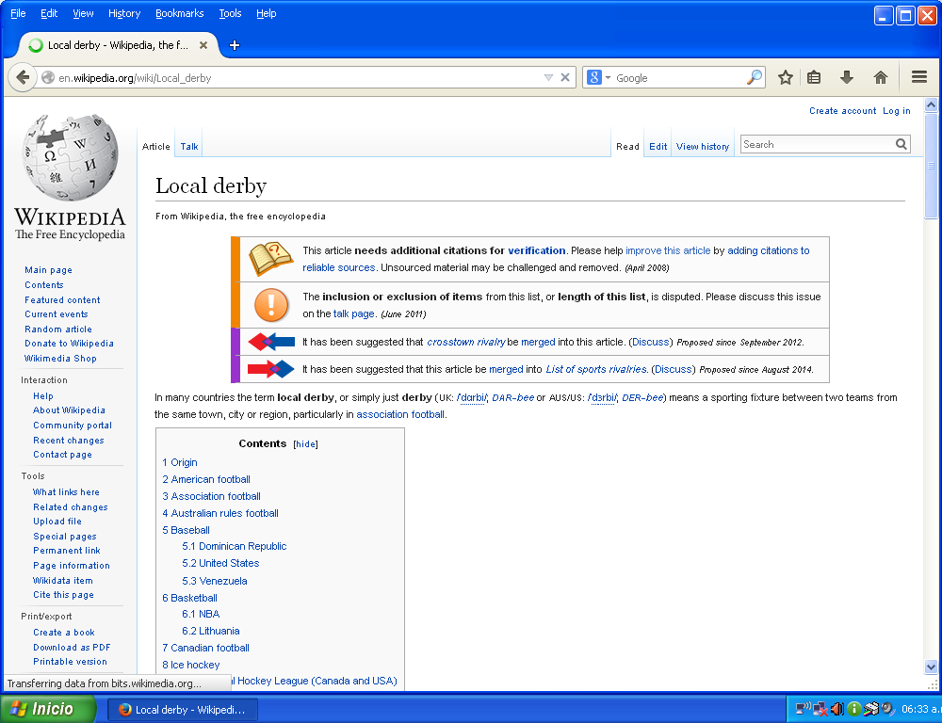
In many countries the term local derby, or simply just derby (UK: /ˈdɑrbi/; DAR-bee or AUS/US: /ˈdɜrbi/; DER-bee) means a sporting fixture between two teams from the same town, city or region, particularly in association football.
Origin
The phrase most likely originated from The Derby, a horse race in England, founded by the 12th Earl of Derby in 1780, since at least as early as 1840 'derby' has been used as a noun in English to denote any kind of sporting contest.
Another widely reported theory, though not accepted by the Oxford English Dictionary, is that the phrase came about from the city of Derby itself.^{[citation needed]} It was renowned as a chaotic and exuberant game that involved the whole town and often resulted in fatalities. The goals were at Nuns Mill in the north and the Gallows Balk in the south of the town, and much of the action took place in the Derwent river or Markeaton brook. Nominally the players came from All Saints' and St Peter's parishes, but in practice the game was a free-for-all with as many as 1,000 players. A Frenchman who observed the match in 1829 wrote in horror, 'if Englishmen call this play, it would be impossible to say what they call fighting'. The traditional Shrovetide football match is commonplace in the town of Ashbourne, Derbyshire."^{[1]}

American football
Main article: National Football League rivalries

Association football
Main article: List of association football club rivalries by country

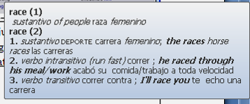


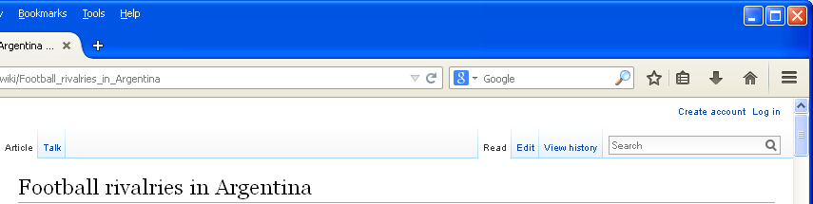
rivalry n | (sport: competition) | rivalidad nf
 |  | competencia nf

Superderby Main article: Superclásico
The Superderby (superclásico) is the most important football rivalry in Argentina, and the most important local derby. It is contested between Buenos Aires rivals Boca Juniors and River Plate. It derives from the Spanish usage of "clásico" to mean derby and the prefix super is used because Boca Juniors and River Plate are the two most popular and successful teams in Argentine football commanding more than 70% of all Argentine football fans between them.^{[1]}

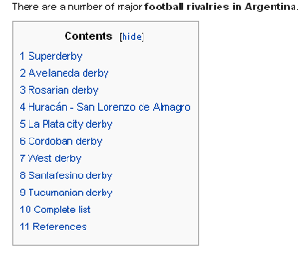
The Superderby is known worldwide as one of world football's fiercest and most important derbies.^{[2]} It is particularly noted for the passion of the fans, the stands of both teams feature fireworks, coloured confetti, flags and rolls of paper. Both sets of supporters sing passionate songs (often based on popular Argentine rock band tunes) against their rivals, and the stadiums are known to bounce with the simultaneous jumping of the fans. Sometimes the games have been known to end in riots between the hardest supporters of both sides or against the police.^{[3]} The English newspaper The Observer put the Superclásico at the top of their list of 50 sporting things you must do before you die.^{[4]}

Superclásico
From Wikipedia, the free encyclopedia
For other uses, see El Clásico (disambiguation).
For the 2011 Danish film, see SuperClásico.
Superclásico is the name used to describe the football match in Argentina between Buenos Aires rivals Boca Juniors and River Plate. It derives from the Spanish usage of "clásico" to mean derby, with the prefix "super" used as the two clubs are the most popular and successful clubs in Argentine football. According to some statistics, they commandeer more than 70% of all Argentine football fans between them,^{[1]} with Boca claiming 40% and River 33%.
The Superclásico is known worldwide as one of the fiercest and most important derbies.^{[2]} In April 2004, the English newspaper The Observer put the Superclásico at the top of their list of "50 sporting things you must do before you die", saying that "Derby day in Buenos Aires makes the Old Firm game look like a primary school kick-about."^{[3]}

ACTIVIDADES:
- Dar la versión en español de:
2. ¿Cuántas teorías hay sobre el origen del nombre?
a. Subrayar los marcadores
b. ¿A qué se refiere cada una?

- Derby
- Superderby
- Superclasico

Association football
Main article: List of association football club rivalries by country

Association football
Main article: List of association football club rivalries by country

Association football
Main article: List of association football club rivalries by country

- Seguir el link correspondiente hasta encontrar el sector de nuestro país, y elegir un clásico para explicar, y explicar contenido.

American football
Main article: National Football League rivalries

Association football
Main article: List of association football club rivalries by country

- Ingresar al siguiente link y completar las tareas
http://observer.theguardian.com/osm/story/0,,1182710,00.html

Decidir si la fuente es confiable ……………………………………………………………………………………
El artículo es el resultado de………………………………………………………………………………………….
Los que participaron………………………………………………………………………………………….
Los méritos que les atribuye………………………………………………………………………………………….

Association football
Main article: List of association football club rivalries by country

